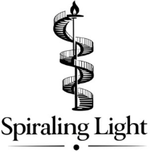 | LIGHT UPON LIGHT:  A Formed by the Word Commentary on 1 John  Author: Craig Fredrickson

Project Overview
Light Upon Light is a spiritually formative commentary on 1 John written as complete, ready-to-teach lessons for churches, classrooms, and Christian study environments. It blends close textual analysis, theological depth, and pastoral guidance in a structure designed not only to inform the mind but to form the heart.
Each chapter functions as both commentary and curriculum. It moves from exegesis to theological reflection to spiritual practice, drawing readers into the recursive pattern of 1 John, where themes such as light, love, assurance, confession, and abiding continually return and deepen.
Distinctives
- Lesson-ready format: Each chapter is built as a complete teaching unit with outline, exposition, formation, application, and a printable handouts.
- Spiritually formative approach: Moves from exegesis to spiritual practice with theological integrity and pastoral care.
- Built for churches: Shaped by high-quality scholarship and engagement with primary commentators on 1 John.
- Recursive design: Captures the spiraling structure of John’s thought, providing readers with an interpretive framework rarely employed in contemporary commentaries.
- Ideal for group use: Equips leaders to teach directly from the material without additional preparation.
Why This Commentary?
Churches increasingly seek resources that combine solid exegesis, pastoral wisdom, and spiritual formation. Traditional commentaries often excel at analysis but leave teachers without a clear pathway to formation. Conversely, modern formation resources often lack exegetical grounding.
Light Upon Light occupies a gap long acknowledged but rarely filled:
- A commentary designed for teaching.
- A formation resource grounded in the biblical text.
- A structure that mirrors the theological movement of the letter.
- A complete curriculum for adult discipleship, lay training, and seminary-level teaching.
Churches regularly ask for resources that bridge commentary precision and discipleship usability. Light Upon Light is designed to meet exactly that need.
Audience: | Pastors and preaching teams  Adult Sunday school & discipleship ministries  Seminary and Bible college students | Small group leaders & lay teachers  Thoughtful Christian readers seeking spiritually grounded formation
Contact:
Craig Fredrickson, Writer, Teacher, and Creator of the Formed by the Word Series
Website: SpiralingLight.com
Email: craig.fredrickson@spiralinglight.com
Commentary Structure
- Text & Context – literary, canonical, and historical framing
- Exposition – careful verse-by-verse interpretation
- Theological Threads – doctrinal synthesis and implications
- Formation & Practice – spiritual application rooted in the passage
- One-Page Handout – teaching outline, reflection questions, and guidance
This structure allows the commentary to serve both as a reference tool and as a complete, ready-to-use teaching curriculum.
The Formed by the Word Series Vision
Light Upon Light is the inaugural volume of a projected ten-volume spiritually formative commentary series. Each volume blends close exegesis, theological clarity, and spiritually formational rhythm to help believers internalize Scripture.
Current and future volumes include:
Drafted:  1 John (Light Upon Light)  Micah (Mercy Upon Mercy)  1 Peter (Grace Upon Grace) | Under Development:  Philippians  Galatians  Hebrews | 2 Corinthians  Malachi  Psalms of Ascent
The series offers a unified, distinctive approach to biblical commentary that integrates exegesis, theology, and formation—ideal for churches, Christian education, and discipleship programs.
Positioning & Comparable Works
This commentary sits at the intersection of: | - Pastoral commentaries (Stott, Boice, Akin)  - Accessible theological reflection (Keller, Ortlund, Bruner)  - Spiritual formation (Mulholland, Nouwen)
Closest comps include: | - Stott’s Tyndale & BST volumes -- clarity, pastoral warmth, theological precision.  - Akin (NAC), Wilkin & Akin (Exegetical Guide) -- pastoral accessibility  - Mulholland -- Scripture-centered spiritual formation with theological depth.  - Nouwen – spiritual formation sensibility -- not exegetical
Light Upon Light is distinct in offering: | - Lesson-ready chapters  - Recursive-structure analysis  - Integration of formation practices  - Paired handouts for group use  - Adaptability to churches, classrooms, and discipleship cohorts  - Select chapters include brief Puritan-inflected devotional ruminations.

Author Qualifications: Craig Fredrickson has taught adult Sunday school for fifteen years across PCA, SBC, and CMA contexts. He is the author of multiple theological and narrative works, including The Week That Broke the World (Holy Week narrative), Glass and Steel (poetry, forthcoming from Shanti Arts), and essays for byFaith, Ad Fontes, and other publications. With a background in operational leadership, Craig brings clarity, structure, and a gift for communicating deep truth with pastoral sensitivity.
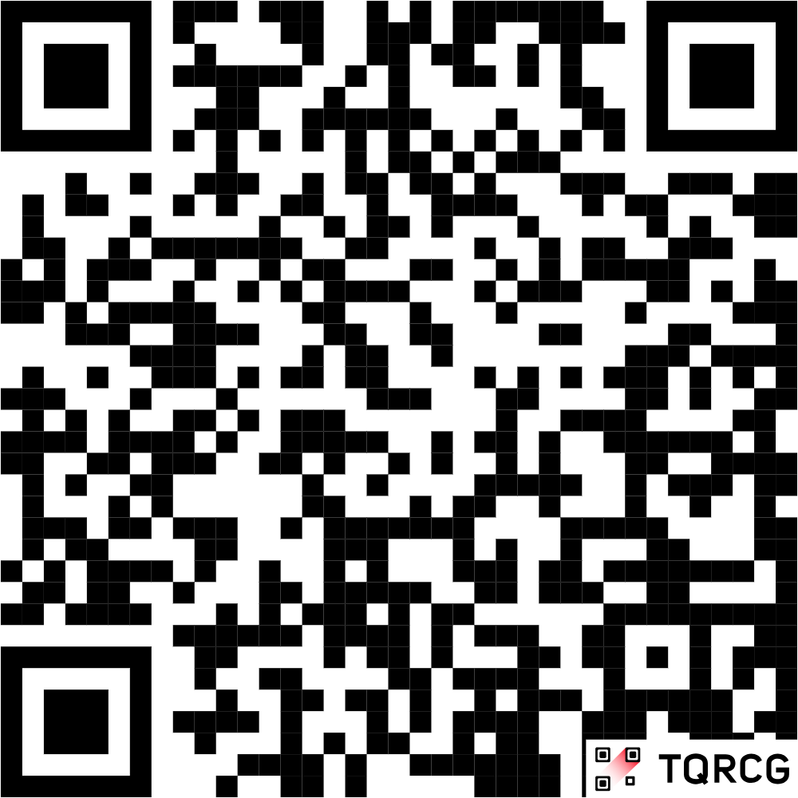
Sample Materials | Please visit this web page for:  - A full sample chapter  - The matching lesson handout  - Introductory material  - Series overview  - Two-page prospectus (this document)

